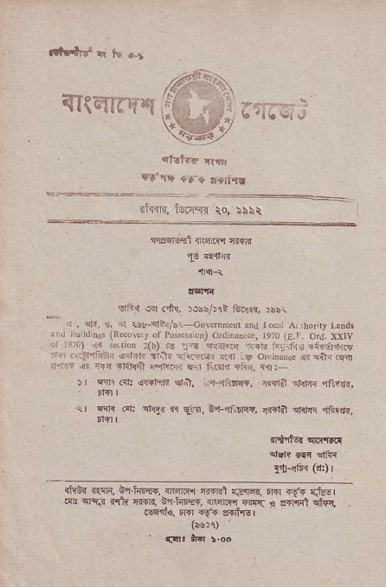
iaTRli
^{it<fi, lginR} io, :sNt
%
ff 615rfl _{{nrnarq} :rtrsld
^{,!6} {irri_4
lrerri
_{slii:t} ^{q} di!, ^{:.rib^rl} teris, )ibi
{ , ^{qfr.} !. ^{ri} *L-el-/ni-cordd.Ent ard roc,i _{A!,no.ny} jinds rn,r ru,rdnss _{(Rrcovoy of} ^{pG$$ion) ordjDin.c, re70} _{{E.r.} orJ. rxry o i;) ^{$ ..'io} _{,o),,} -...rr*n
^{r ..f4.jF j.i.<!r'n..s..j} ?d b o,..,.. , _{4,} ^{qitr} .fl _{,r,lrF} ^{qi} _{1ia ?r{E-nil} ^{j"4t'r1} sr ^{f dr,} _{"i?n,} rt:
_{ir F4rl} (1r q?hlr _{qr+,} ^{'.i+?afi+,} r?Hl ^{errhi} "itiran, _{1.} ^{qli} @t cftI, rr qiq, _{E} ^{-f,;ttr{,} lr{ia sfrmr lFftr.,
_{ltdir} (d:) |
iffi. ialrr, €q-trffi{. .rqnI{ _{{{+ril} ^{qjqiqn} rm rr{ m cFqi +rh ffi, ^{bl} _{hry{,} ^{EiriE4} FiI'i 4 sT'r'fi .56l'1€. ol{r .f{ ?f{irE'
^{tbE!1) '} (i!t lF !.oo

